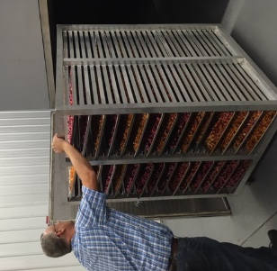
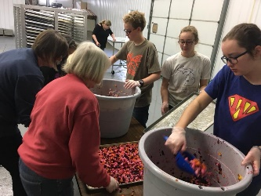
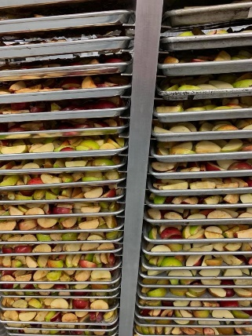
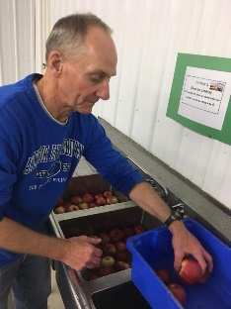
Volunteer Training Session
Thursday, December 27
(1:00-4:00PM)
2464 Wilshere Drive
Jenison, MI 49428
*Blue Warehouse; park wherever you can find a spot
We are so excited you are joining us for our FIRST EVER Group-Training Session with Sus Manos Gleaners (SMG). Our goal in this afternoon session will be simple, we are hoping to help you and others become a little more familiar with the ministry and what is involved in a day with volunteers.
At this time we do not have a steady operating schedule as we need to grow our volunteer base and help each feel confident and comfortable working in the building. We’d like to encourage you to consider inviting a group of friends or family, perhaps a church group to come out and volunteer for an upcoming Saturday session (we can usually schedule around your request at this time). If you host a group with us, we’d like to challenge you to join us in taking the lead for that day – arriving early to set up, perhaps leading the group in the devotions, and giving volunteers key reminders before starting and also at the end of the day for cleaning up.
Based on this, our agenda for today is to go through all that is needed to be successful in hosting groups at the site. We will even do a batch of veggies together in this training session!
Our Training Agenda:
1:00PM ~ Arrive at the building, come on in and grab a cup of coffee; Group introductions in the devotions circle area
1:15-1:30PM ~ Devotions led by Jim Paauw, SMG board president
1:30-1:50PM ~ A brief history of Sus Manos Gleaners and how we came to be, led by Tim Paauw
1:50-2:15PM ~ Overview of Key Set-up & Operating Procedures, led by Jim Paauw with support of SMG Board Members
2:15-3:15PM ~ Group running a load of produce from step 1 to loading the dehydrator
3:15-3:45PM ~ Group Q & A
3:45PM ~ Wrap up / Prayer
(don’t forget to turn the heat off & the water-heater circulating pump switch before locking up)

